[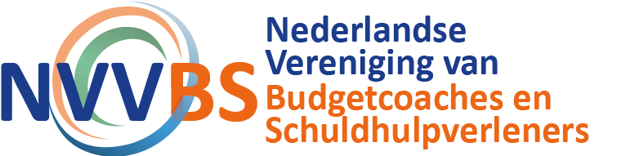](https://community.nvvbs.nl/)